Top 10 Factors That Determine the Cost of E&O Insurance for Agencies:
How much should I expect to pay for Errors & Omissions (E&O) insurance is a common question among agency owners, or for those looking into starting their own agency.
Like most things in our industry, the answer is: it depends. E&O premiums are calculated based on a wide range of factors—each designed to assess the agency’s risk of making a mistake and the likelihood of that mistake resulting in a claim. For agency owners, especially those managing growth or launching new ventures, understanding these variables is essential.
Here are the key factors influencing E&O pricing today:

1. Size of the Agency
Underwriters look at premium volume, revenue, number of employees, or even total accounts. While each carrier has its preferred metrics, they’re all attempting to size up your exposure.
2. Book of Business Composition
What you write matters. Agencies focused on standard personal lines are typically viewed as lower risk than those writing complex or hazardous commercial accounts like construction, energy, or environmental.
3. Limits and Deductibles
The higher the limits, the higher the premium—no surprise there. However, deductible structure can be just as important. Some deductibles apply to loss only, while others apply to both loss and defense costs. That distinction can significantly impact the premium.
4. Geographic Location
E&O is based largely on the legal concept of negligence, and “standard of care” can vary by state—and even county. Some carriers factor in the local legal environment, including jury behavior and the potential for "nuclear verdicts."
5. Staff Experience and Training
Experienced, credentialed staff reduce risk. Designations, tenure, and ongoing education are strong signals to underwriters that your team is well-equipped to avoid costly errors.
6. Use of Technology and SOPs
Agencies with strong Standard Operating Procedures (SOPs) and solid tech stacks are often more consistent and better documented—two things that matter greatly in an E&O claim.
7. Claims History
Recent claims, particularly if they’re unresolved or involve large payouts, will drive up your rate. Underwriters evaluate not just the presence of claims, but how you responded and whether operational improvements were made.
8. Risk Awareness and Proactive Management
Agencies that undergo E&O-specific training or bring in external experts for an E&O review or audit are demonstrating a commitment to prevention. Some carriers recognize and reward that.
9. Owner Experience (Especially for Start-Ups)
For new or start-up agencies, the experience of the owner plays a pivotal role in both pricing and eligibility. A founder with a solid track record and a clean claims history is far more appealing to carriers than one new to the business. In fact, some carriers may decline to quote entirely if the owner lacks adequate experience.
10. Additional Services Offered
If your agency provides services beyond traditional insurance—like COBRA administration, HR consulting, or acting as a TPA—expect that to impact your premium. These services often expand your exposure profile and may even require separate underwriting considerations.

Real-World Pricing Benchmarks
To illustrate how these factors come together in practice, here are several recent E&O policies placed for a variety of agency types:
- $91M Gross Written Premium | 77% Commercial Lines
$4M/$8M limits, $25K/$75K deductible (Loss & Expense)
Premium: $108,467
- $57.5M GWP | 65% Personal Lines
$5M/$5M limits, $5K/$10K deductible (Loss Only)
Premium: $71,583
- $18M GWP | 60% Personal Lines
$4M/$4M limits, $5K/$15K deductible (Loss Only)
Premium: $19,367
- $9.3M GWP | 70% Commercial Lines
$5M/$8M limits, $10K/$30K deductible (Loss Only)
Premium: $10,368
- $1.9M GWP | 75% Personal Lines
$2M/$4M limits, $5K/$15K deductible (Loss Only)
Premium: $4,104
These examples show just how dramatically premiums can shift based on agency size, book mix, limit structure, and more.

The Takeaway
E&O pricing is not arbitrary—it’s the product of how your agency is viewed through the lens of risk. And that perception can be influenced. Agencies that invest in staff training, adopt consistent processes, embrace proactive risk management, and work with experienced advisors put themselves in a stronger position.
If you’re serious about protecting your business, surround yourself with people who understand E&O deeply and are committed to helping you understand it too. Your State Big “I” Association would be a great place to start that conversation.

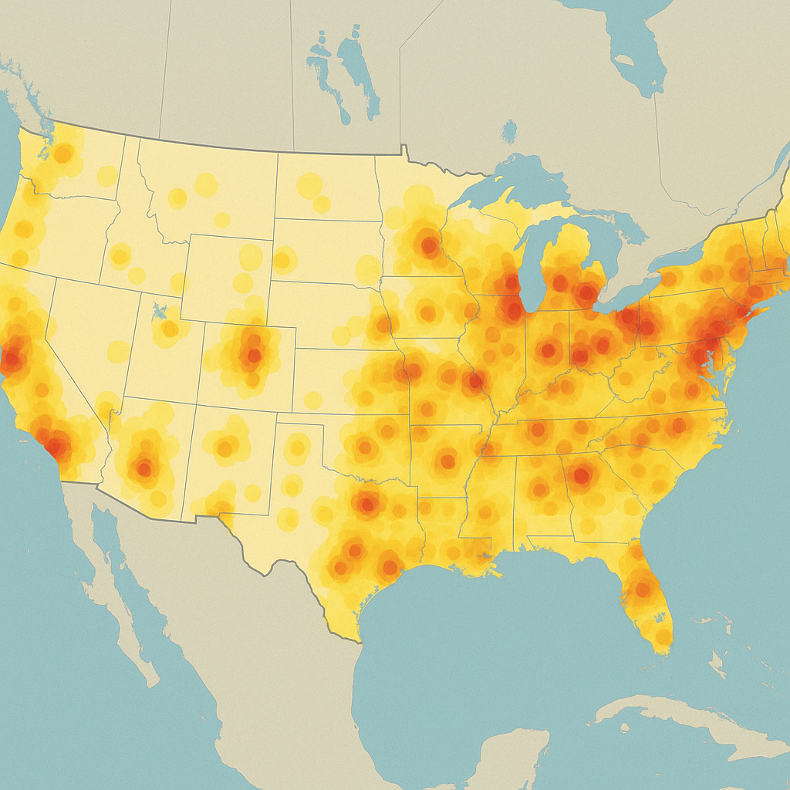

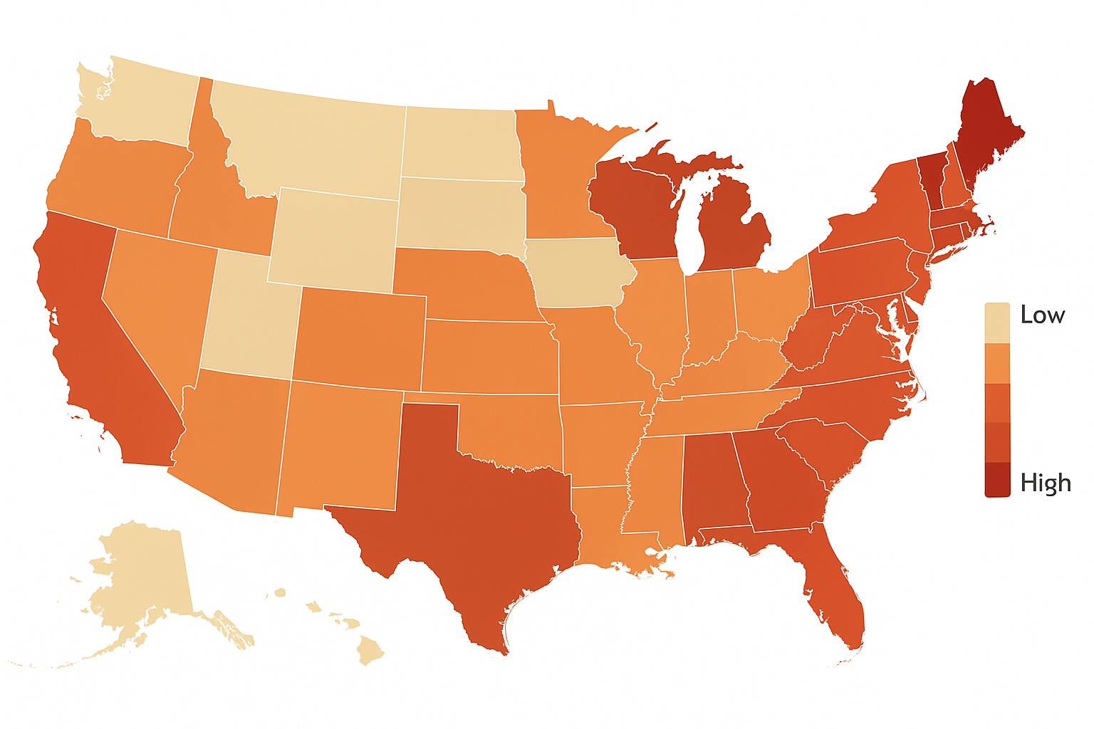

"Heatmap represents relative risk for E&O litigation severity based on publicly available reports, including the ATRF Judicial Hellholes® ranking and aggregated claims intelligence from industry partners."

